Name ____________________________ AP Calculus
Chapter 2 Review

Part A: A calculator may not be used on this part of the test.

1. $\underset{x→−3}{\text{lim}}(x^{5}−x+5)$=

- If $c≠0$, then find $\underset{x→c}{\text{lim}}\frac{x−c}{x^{2}−c^{2}}$

3. $\underset{x→2}{\text{lim}}\frac{2}{x−2}=$

4. Find the horizontal asymptote of $\frac{4x^{2}+6x}{x^{2}−9}$.

5. $\underset{x→0}{\text{lim}}\frac{\text{sin}x}{4x^{2}−8x}=$

6. What is $\underset{x→∞}{\text{lim}}\frac{x^{3}−2x^{2}+3x−4}{−1+2x−3x^{2}−9x^{3}}$?

7. The graph of a function $f$ is shown below. At which values of $x$ (a,b,c,d,e) is $f$continuous?

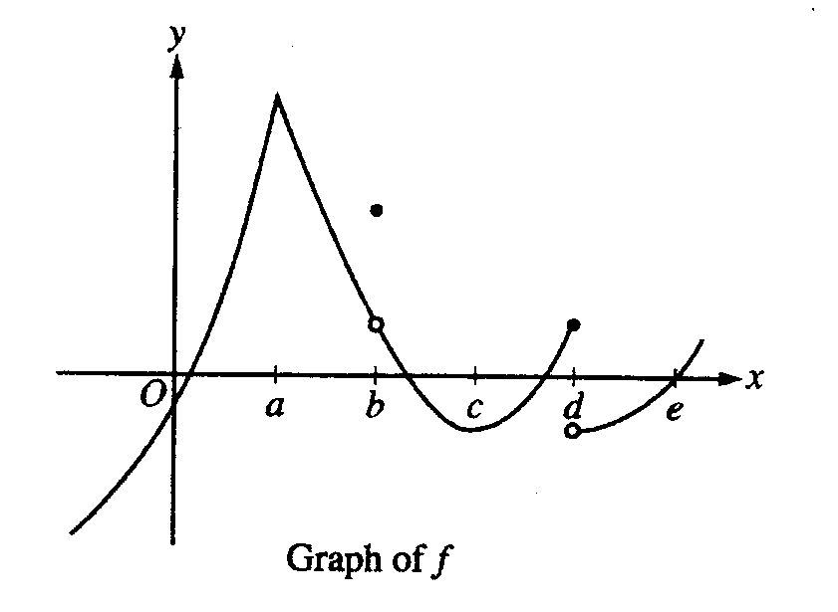

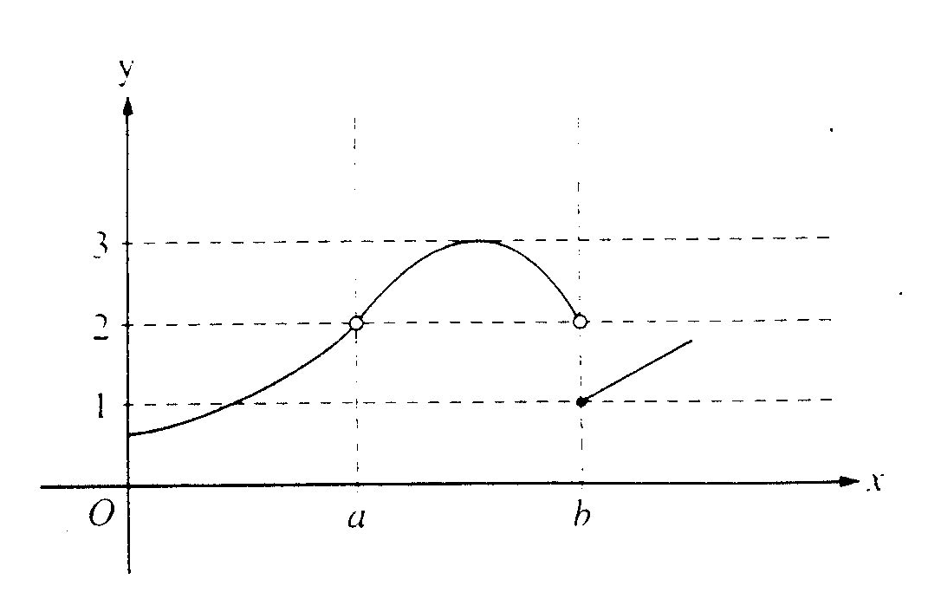
8.

The graph of the function $f$ is shown above. Which of the following statements is true?

(A) $\underset{x→a}{\text{lim}}f(x)=\underset{x→b}{\text{lim}}f(x)$
(B) $\underset{x→a}{\text{lim}}f(x)=2$
(C) $\underset{x→b}{\text{lim}}f(x)=2$
(D) $\underset{x→b}{\text{lim}}f(x)=1$
(E) $\underset{x→a}{\text{lim}}f(x)\text{ does not exist}\text{.}$

9. Let $f(x)=\begin{aligned}\left\{3x+6\text{ if }x≤5 | \right.\end{aligned}$

Find $\underset{x→5}{\text{lim}}f(x)$
Is $f$ continuous at x = 5?

10. If $f(x)=\begin{aligned}\left\{e^{x}\text{ for 0}<x≤3 | \right.\end{aligned}$ find $\underset{x→3}{\text{lim}}f(x)$
11. What is the average rate of change of the function $f$ given by $f(x)=2x^{2}+6x+\text{10}$ on the closed
interval [1, 5]?

12. Given the function $f(x)=x^{2}−4x+8$, use the intermediate value theorem to show that the equation $f(x)=5$ must have at least two solutions in the interval [-1, 4].
Name ____________________________ AP Calculus
Chapter 2 Review

Part B: A graphing calculator is required for some of the questions on this part of the test.

13. Let $f$ be the function given by $f(x)=x^{6}3^{x}$. Find $\underset{x→∞}{\text{lim}}f(x)$ and $\underset{x→−∞}{\text{lim}}f(x)$.

14. Consider $y=2x^{2}+6x$ when x = –4.
a) Find the slope of the curve at that point.
b) Write the equation of the tangent line at that point.
c) Write the equation of the normal to the curve at that point.

